**1) Entity:-** The Entity is ‘thing’ (or) ‘Object ‘ in the real world. An entity is distinguishable from other objects by set of attributes.

Examples:

1. Entities related to Bank: Customer, Account, Employee…etc.
2. Entities related to College: Student, Lecturer, Course, Library…etc.
3. Entities related to Hospital: Doctor, Patient, …etc.

**2)Attribute:-**The Property/Characterstic of entity is called as attribute. The property provides some information about entity.

Examples:

Entity Name: Course

Property Names: c_id, c_name , c_duration.

Entity Name: Student

Property Names: r_no , Stu_name , addr , mb_no.

**2.1)Attribute Types:** The attributes have been divided into six types.

1.Simple Attributes.

2.Composite Attributes.

3.Single Value Attributes.

4.Multivalue Attributes.

5.Stored Attributes.

6.Derived Attributes.

.

1.Simple Attributes:The attribute that is not divisible is called as 'simple or atomic attribute'.

Examples:cust_name, acc_no etc..

The simple attribute symbol is:

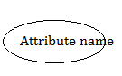

The key attribute symbol is:

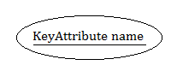

2.Composite Attributes:The attribute that can be divided into smaller subparts, which represent more basic attributes with independent meaning is called as Composite Attribute.

Example:Address.

Address can be divided into 3 simple attributes Such as

Street_Name

DrNo

City.

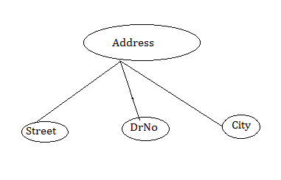

3.Single Value Attribute:The attribute having a single value for a particular entity is called as 'Single Valued Attributes'.

Example:'Age'

4.MutiValue Attribute:The attribute, which are having a set of values for the same entity, are called as 'Multi Valued Attributes'.

Example:1 College Degree.

A 'College Degree' attribute for a person.i.e, one person may not have a college degree, another person may have one and a third person may have 2 or more degrees.

Example:2 Mobile_No

A person may have 2 or more mobile numbers.

A multi-valued attribute may have lower and upper bounds on the number of values allowed for each individual entity.

The multivalue attribute symbol is:

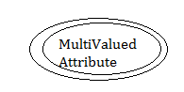

5.Derived Attributes:

An attribute whose value is derived from another attributes is called as a ‘derived attribute.

Example: Age

‘Age’ attribute value is derived from another attribute ‘Date’ and ‘DOB’.

The Derived Attribute symbol is:

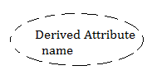

6.Stored Attribute:An attribute whose value is not derived from another attributes is called as a ‘stored attribute.

Example:

In the above example,’ Date’ is a stored attribute.

**3.Entity Set:**The entity set is group of similar entities. All entities share the same attributes.

EX:- Collection of Bank Customers.

Collection of Students in class room.

3.1) Entity set Types:- There are two types of Entity sets.

1. Strong Entity Set.
2. Weak Entity Set.
3. Strong Entity set:- A strong entity set is entity set that contains key attribute to Uniquely identify all its entities. The strong entity set is symbolically represented by rectangle enclosing its name.

Entity set Name

1. Weak Entity set:- A weak entity set is entity set that don’t contains key attribute to uniquely identify all its entities. Weak Entity Symbol is

Weak entity set Name

**4.Relationship:**It is an association among entities. The Relationship may have attributes. These attributes are called ‘descriptive’ attributes. These are used to record information about the relationship.

Ex1:- raghu join in M.tech on 7-june-2020.

Where

Relationship is join.

Descriptive attribute name is Date.

Two entities are raghu and M.tech.

Descriptive attribute contains joining date(7-june-2020).





4.1) Relaionship Models:-There are 3 relationship models in ER-model.

a)Unary Relationship(recursive).

b)Binary Relationship.

c)Ternary Relationship.

d) N-aryRelationship

A)Unary Relationship:when there is only one entity set participating in relationship then such type of relationship is called unary relationship.

Ex:University might keep track of which employees supervise other employees.

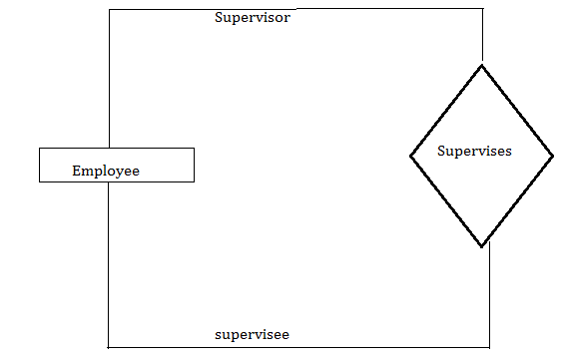

B) Binary Relationship:-when there are exactly two different entity sets participating in relationship then such type of relationship is called binary relation ship.

Ex:- university might need to record which student join in which course.

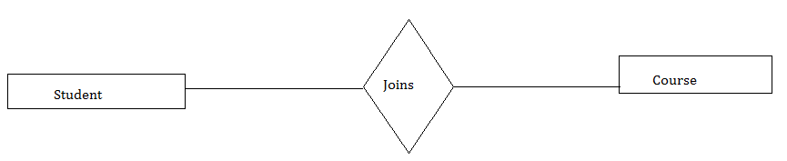

C)Ternary Relationship:-when there are exactly 3 different entity sets participating in relationship then such type of relationship is called ternary relation ship.

Ex:-University might need to record which teachers taught which subject in which course.

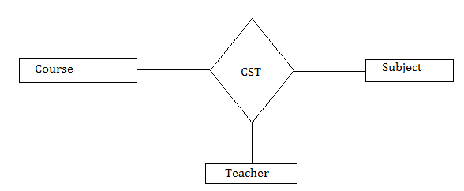

d)N-ary Relationship:- when a large number of different entity sets are participating in relationship, then such type of relationship is called n-ary relationship.

4.2) Degree:-The ***degree*** of a relationship is the number of entity types/entity sets that participate in the relationship.

Binary= degree 2.

Ternary=degree 3.

N-ary=degree n.

**5.Relationship Set:**A set of relationships of similar types is called a relationship set. The Relationship set symbol is:

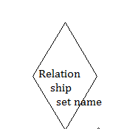

**6.Additional Features of the E-R Model**

**6.1.Key Constraints:**Constraints are used for modeling limitations on the relations between entities. There are two types of constraints on ER model.

1. Mapping Cardinality/cardinality ratio.
2. Participation constraints.

A)Mapping Cardinality:- It express the no.of entities to which another entity can be associated via relationship set. For binary relationship set there are entity set A and B,the mapping cardinality can be one of the following.

* + One-to-one
  + One-to-many
  + Many-to-one
  + Many-to-many

1)One-to-one: One entity from entity set A can be associated with at most one entity of entity set B and vice versa.

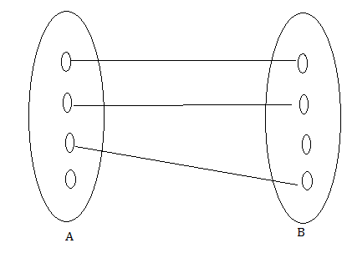

Example: - A person has only one passport and one passport is given to only one person.

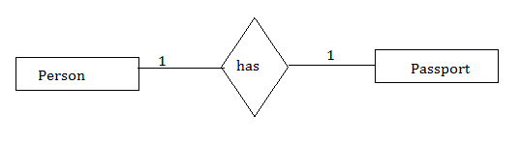

2.One-to-many:One entity from entity set A can be associated with one or more than one entity of entity set B however an entity from entity set B, can be associated with at most one entity in A.

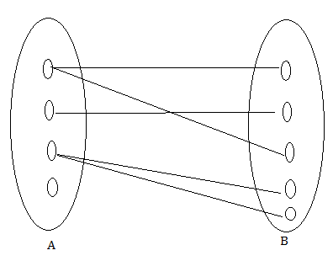

Ex: Customer can place many orders but a order can not be placed by many customers.

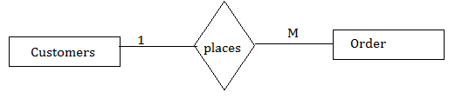

3.Many-to-one:More than one entities from entity set A can be associated with at most one entity of entity set B,however an entity from entity set B can be associated with more than one entity from entity set A.

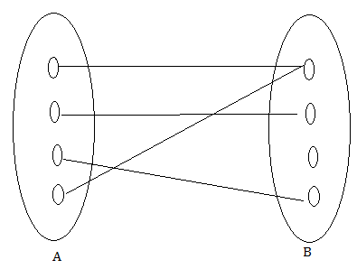

Ex: Many students can study in single college but a student can not study in many colleges at the same time.

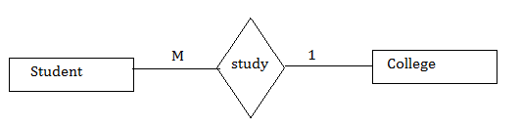

4.Many-to-Many: One entity from A can be associated with more than one entity from B and vice versa.



EX: A student can be assigned to many projects and project can be assigned to many students.

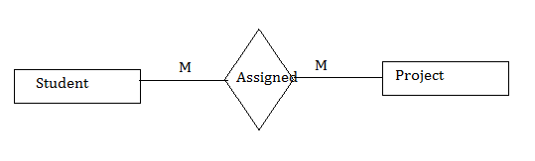

**B).Participation Constraints:**There are 2 types of participation constraints, which are as below.

1.Total.

2.Partial.

.

1.Total:If every entity in entity set participates atleast once in relationship set, such participation is called total participation. In E-R diagram, the total participation is displayed as a ‘double line/solid thick line’ connecting the participating entity type to the relationship.

Ex:-Each student must be enrolled at least for one course.

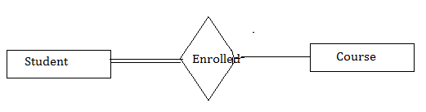

In above diagram Student has total participation.

2.Partial-participation:It specifies that each entity in entity set may or may not participate in relationship set.Partial Participation is represented by singleline connecting entities in relationship.

Ex:- Instructor may advice to 0 student.

**Where instructor has partial participation.**

**6)Weak Entity Set: The** Entity set that do not have key attribute of their own is called as weak entity set.For any weak entity set, following restrictions must hold.

1. The owner entity set and the weak entity set must participate in a One-to-many relationship set, which is called as the ‘Identifying Relationship Set’ of the weak entity set. The Identifying relationship set symbol is:

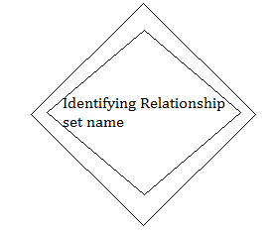

1. The weak entity set must have total participation in the identifying relationship set.

Example:

‘Dependents’ is an example of a weak entity set.

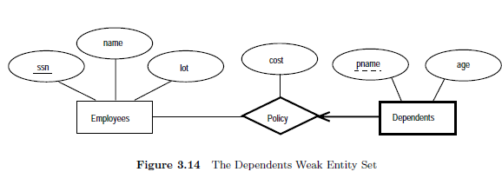

Partial key of the weak entity set:



The set of attributes of a weak entity set that uniquely identify a weak entity for a given owner entity is called as ‘partial key of the weak entity set’.

Example:

‘Pname’ is a partial key for dependents.

|  |  |  |  |  |
| --- | --- | --- | --- | --- |
|  |  |  |  |  |





**7.3Aggregation:**Aggregation allows us to indicate that a relationship set (identified through a dashed box) participates in another relationship set.If we need to express a relationship among relationships, then we should use aggregation.

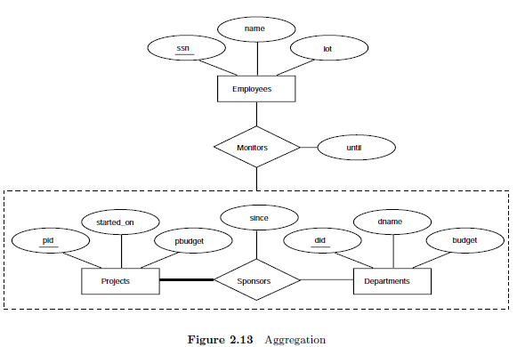



According to the above diagram,

1. A project can be sponsored by any number of departments.
2. A department can sponsor 1 or more projects.
3. 1 or more employees monitor each sponsorship.

(Many to Many Relationship)



7.4**) Class Hierarchy**: Class hierarchy can be viewed in one of two ways.

1. Specialization:- we group the entities that are distinct in some way from other entities in the entity set. This subset of entities have some attributes that are not shared by other entities with in entity set.

In the person, some entities does not share salary attribute and some entities does not share tot-credit attribute. Therefore we can make two sub groups in person entity set. One sub group name is student who does not share salary. Another subgroup name is employee who does not share tot-credit.

Q) what is specialization?

A) The specialization is making subgroup of entities with in entity set. The sub group of entities is called specialized entity set. With in this set,all entities are described by attributes that are not shared by another subgroup. The specialization is represented by

IS-A

Example:

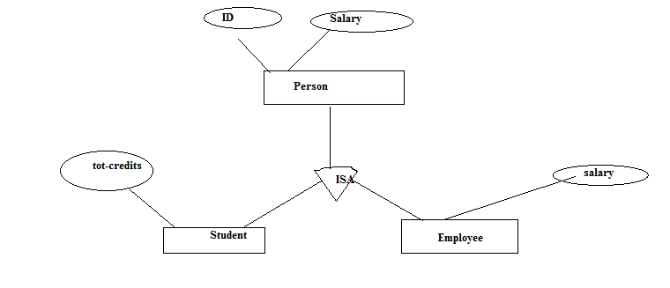

Note:- It is top-to-down design process.

1. Generalization:-The generalization is process of extracting common attributes from entity sets & create generalize entity set from it. It is bottom-to-top design process.

Ex:-

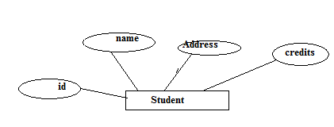

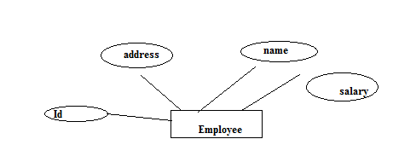

The student and employee entity share common attributes. With common attributes, we create generalize entity set called person.



Note:- It is bottom-to-top design process.